**JIRA Project Management Document**

**Project Title:**

Arms Application for SIMATS Engineering.

**Subtitle:**

Agile Sprint Planning and Execution for Arms Application Development at SIMATS Engineering

**Submitted by:**

Valli Karthik

192324258

Department of AI & Data Science

SIMATS Engineering

**Submitted to:**

Dr. Prakash Mathialagan

**Project Overview**

This document outlines the project management plan for developing an arms application for SIMATS Engineering. The plan includes sprint planning, task breakdown, timeline creation using JIRA, and a list of activities within the sprint. Additionally, it documents meetings that take place before, during, and after the sprint.

**1. Project Setup in JIRA**

To efficiently track and manage tasks, we will use **JIRA** to create a **Scrum board** with the following key elements:

* **Project Name:** Arms Application Development – SIMATS Engineering
* **Board Type:** Scrum Board
* **Sprint Duration:** 3 weeks
* **Team Members:** IT developers, designers, testers, project manager
* **Workflow:** To Do → In Progress → Done

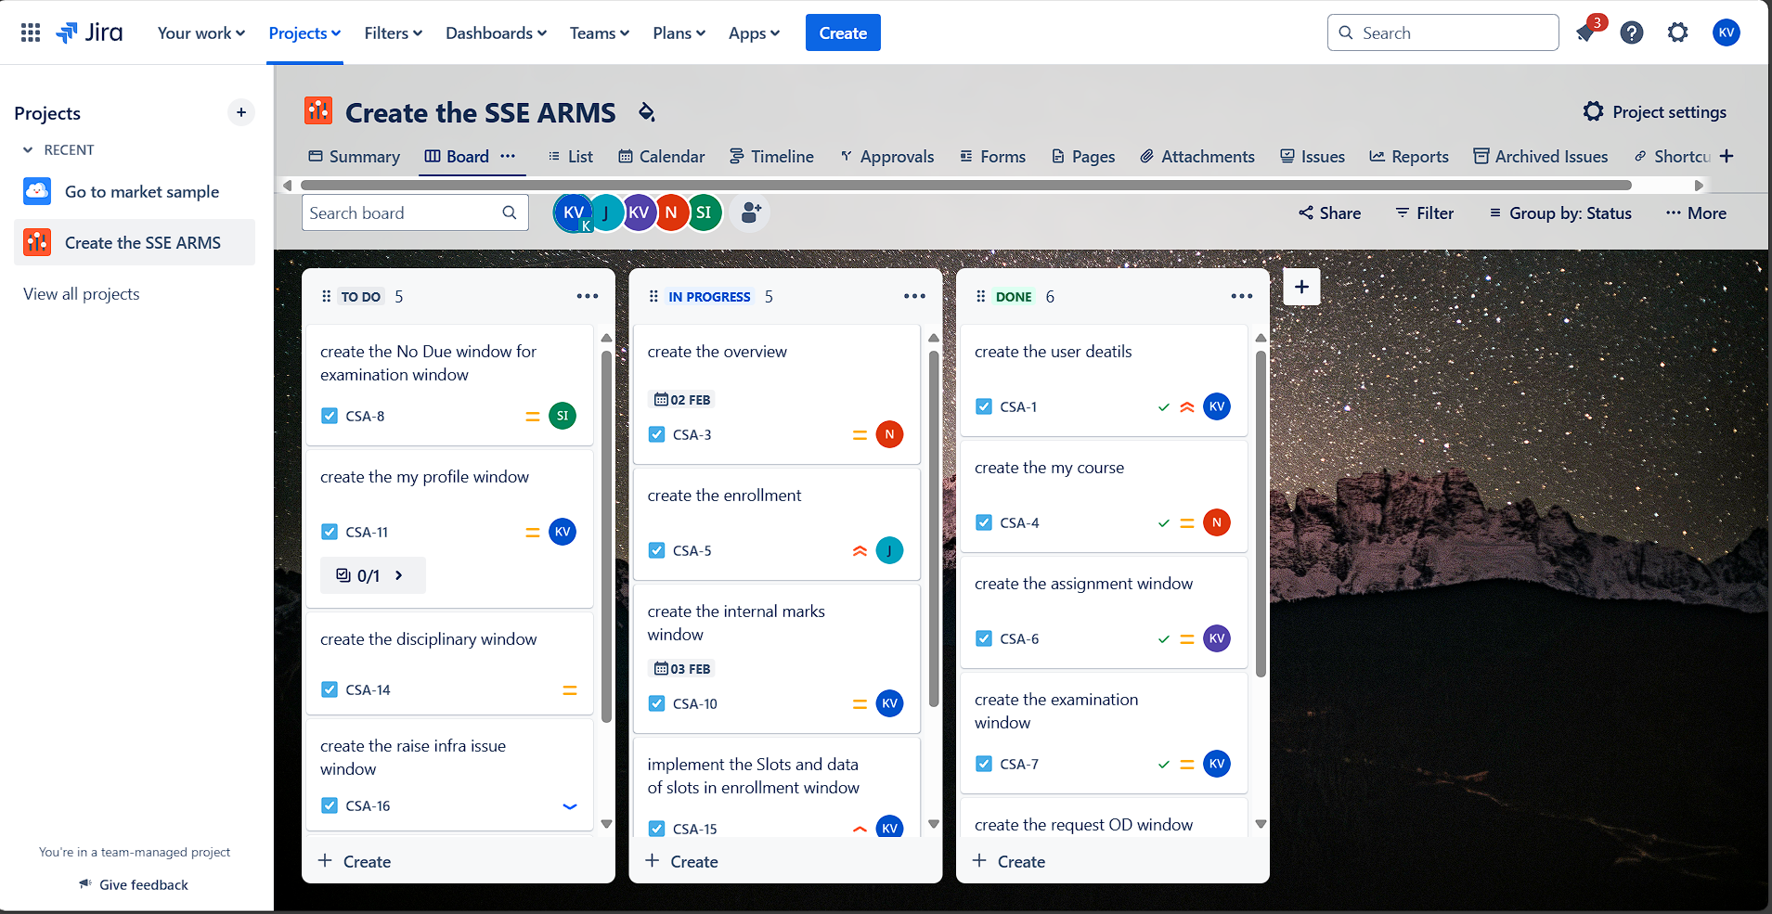

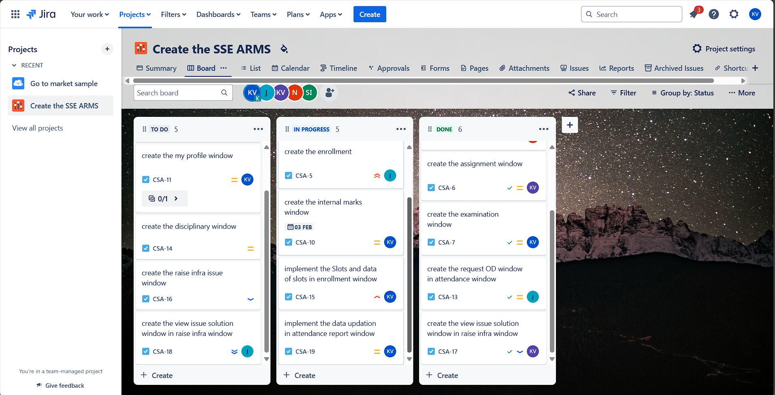

**2. Project Timeline & Sprint Board (JIRA Setup)**

The project will be managed using **JIRA**, where a **Scrum Board** will be created to track the sprint progress. The board will have the following sections:

**To Do** – Tasks selected for the sprint

**In Progress** – Tasks currently being worked on

**Done** – Completed tasks

**Sprint Timeline Board (3 Weeks):**

|  |  |
| --- | --- |
| **Week** | **Milestone** |
| **Week-1** | Sprint Planning, UI/UX Design, Backend Setup |
| **Week-2** | Feature Development, Initial Testing |
| **Week-3** | Final Testing, Deployment, Sprint Review |

**3. Sprint Activities & Task List:**

1. Create the user details
2. Create the overview
3. Create the my course
4. Create the enrollment
5. The assignment window
6. Create the examination window
7. Create the No Due window for examination window
8. Create the internal marks window
9. Create the my profile window
10. Create the request OD window in attendance window
11. Create the disciplinary window
12. Implement the Slots and data of slots in enrollment window
13. Create the raise infra issue window
14. Create the view issue solution window in raise infra window
15. Create the view issue solution window in raise infra window
16. Implement the data updation in attendance report window

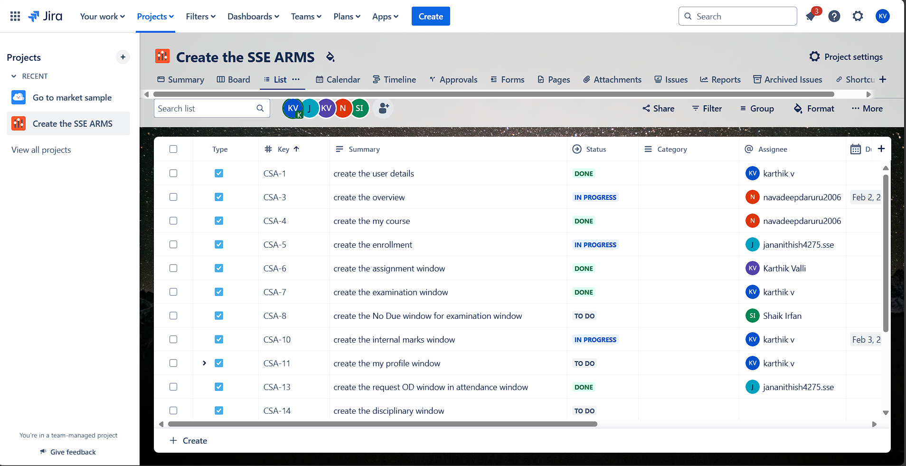

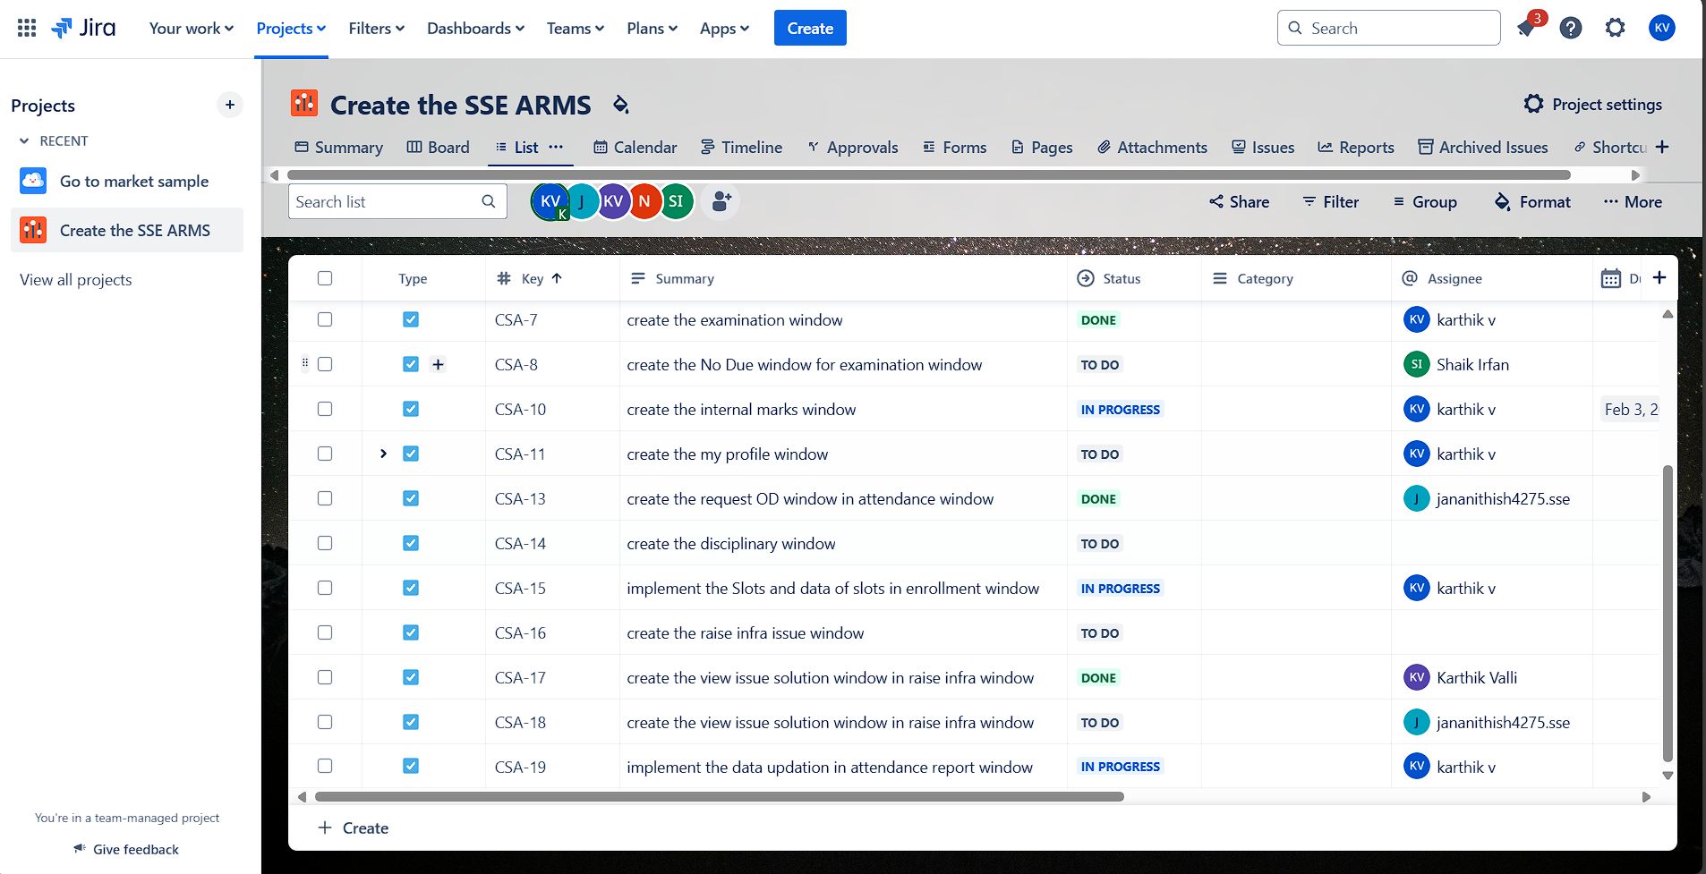

**4. Meetings & Scrum Events**

To ensure smooth execution, the following meetings are planned **before, during, and after** the sprint.

**Before the Sprint**

1. **Project Kickoff Meeting** – Discuss scope, objectives, and expectations.
2. **Sprint Planning Meeting** – Define sprint goals, assign tasks, and estimate story points.

**During the Sprint**

1. **Daily Stand-up (Daily Scrum Meeting)** – 15-minute meeting to track progress & resolve blockers.
2. **Technical Review Meetings** – Discuss architecture, security concerns, and API design.
3. **Code Review Sessions** – Developers review each other's code before merging.

**After the Sprint**

1. **Sprint Review Meeting** – Demonstrate completed work to stakeholders.
2. **Sprint Retrospective** – Discuss what went well, what could be improved, and action points for the next sprint.

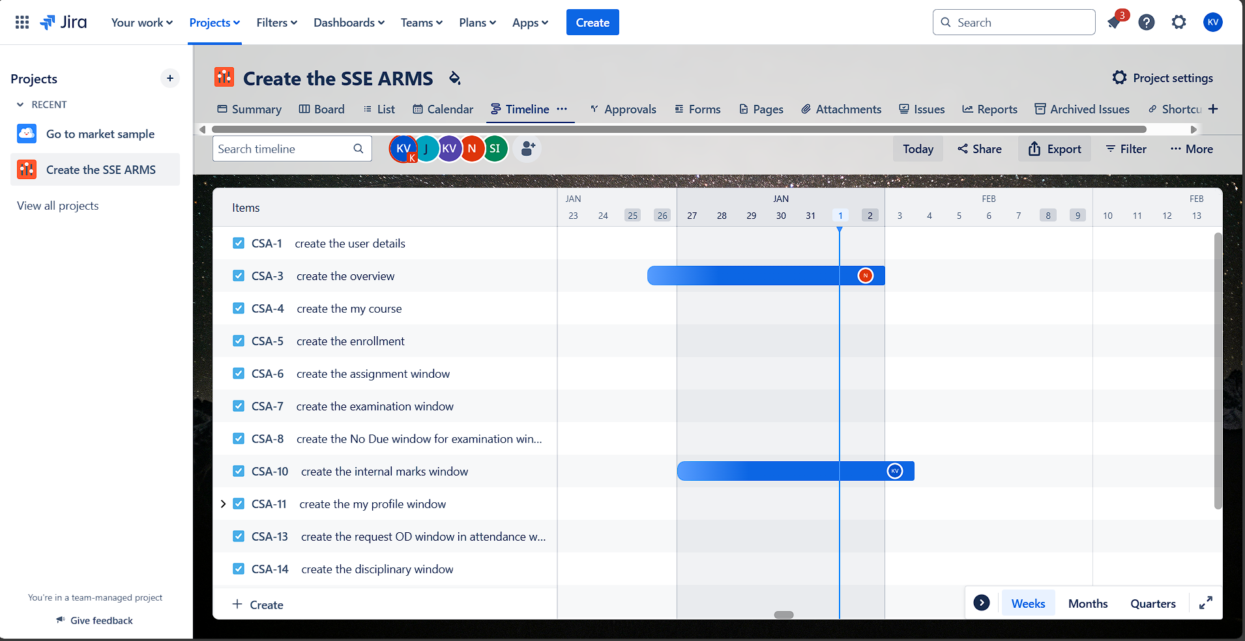

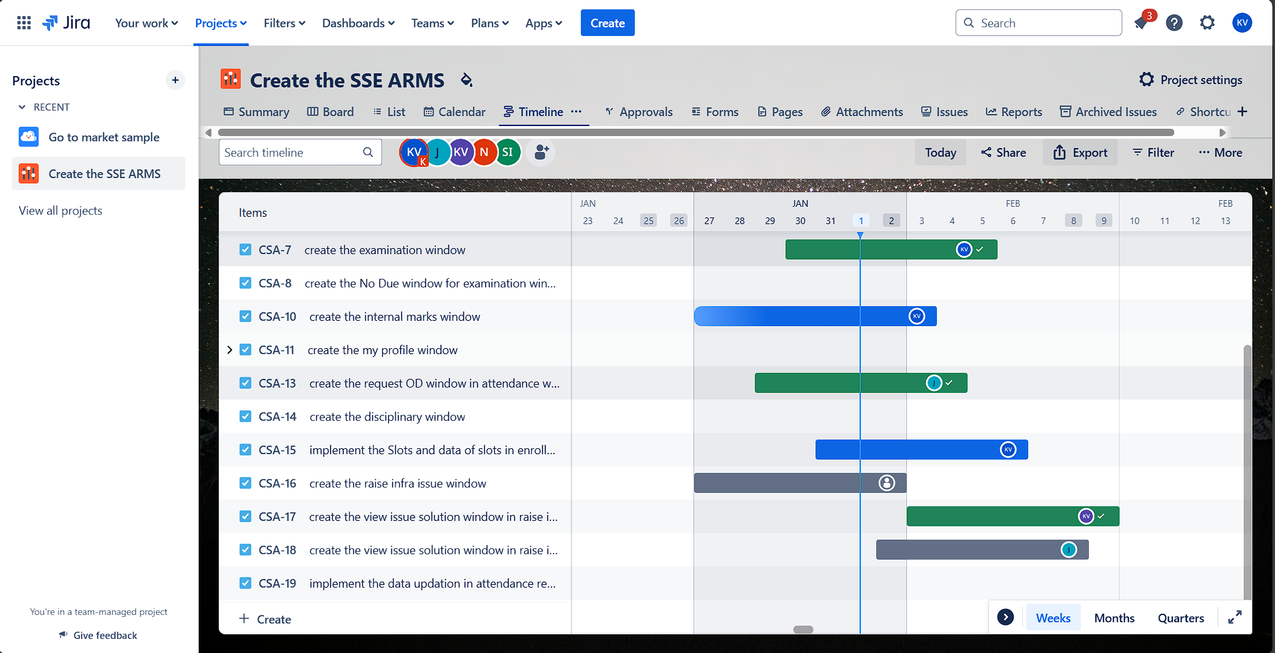

**5. Progress Tracking in JIRA**

* **Kanban Board:** Used to move tasks between workflow stages.
* **Reports Used:**
  + Burndown Chart: Monitored task completion.
  + Task Distribution: Visualized workload across team members.
* **Dependencies Managed:** Linked tasks to avoid delays.

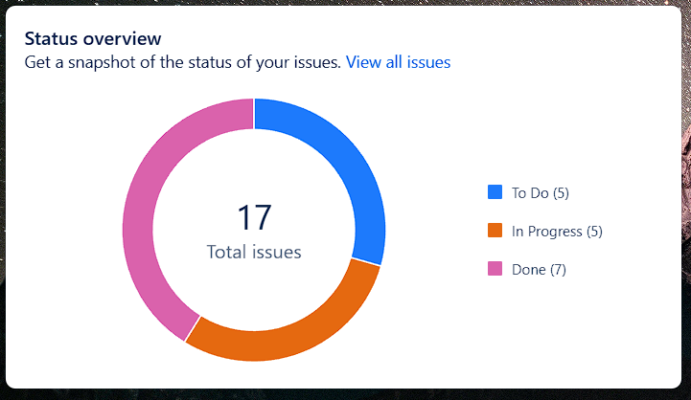

**6. Tools Used Alongside JIRA**

* **Confluence:** For centralized project documentation.
* **Slack:** For team communication and daily stand-ups.
* **GitHub:** Code repository for version control.

**Summary:**

The project, **Development of Arms Application for SIMATS Engineering**, was effectively managed using JIRA's Project Management template. The primary objective was to streamline task tracking, improve team collaboration, and ensure timely delivery of the application.

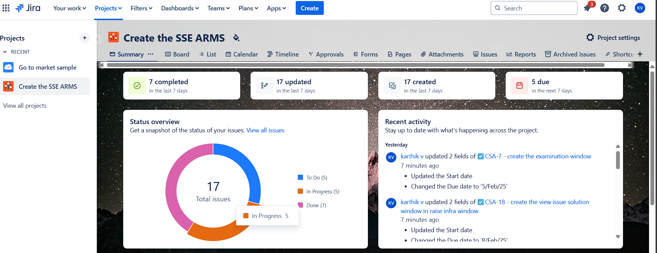

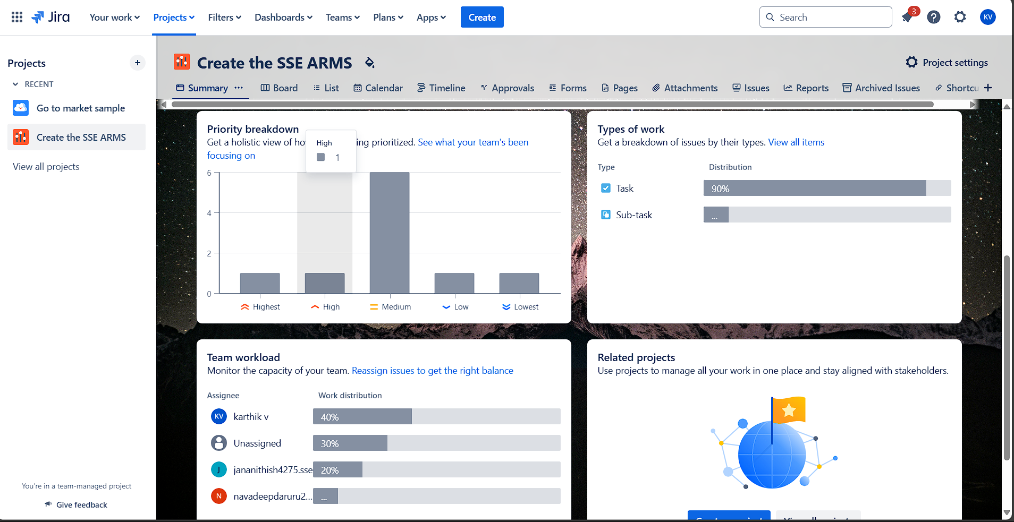A total of **15 tasks** were created in JIRA, categorized into the following statuses:

* **Done:** 7 tasks successfully completed.
* **In Progress:** 5 tasks currently under development.
* **To Do:** 4 tasks awaiting initiation.

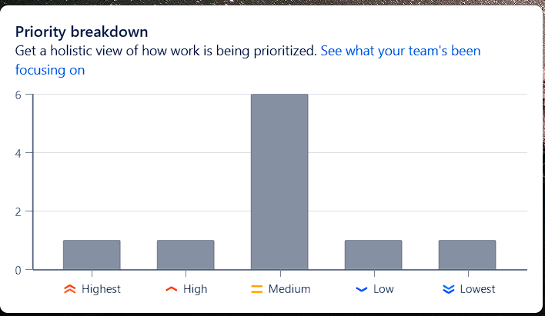

Key features of JIRA, including the Kanban Board, Timeline (Roadmap), and Reports (such as Burndown Chart and Task Distribution), were employed to effectively monitor and manage the workflow. Regular meetings, such as kick-off meetings, daily stand-ups, sprint reviews, and retrospectives, were held to ensure team alignment.

The project utilized JIRA's comprehensive task tracking and dependency management tools, enabling the team to stay productive and focused while adhering to project deadlines.

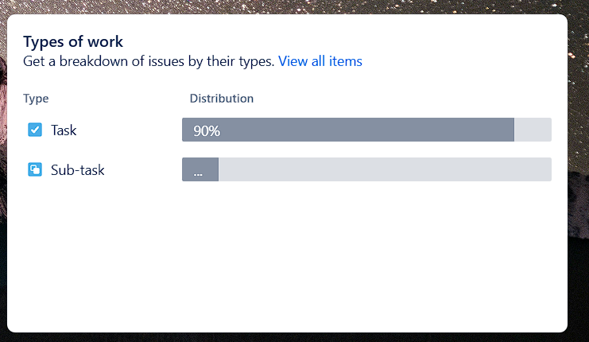

**6. Conclusion**

This structured Agile-based project management plan ensures smooth execution, transparency, and accountability for the ARM Application Development at SIMATS Engineering. By leveraging JIRA, the team can effectively track progress, mitigate risks, and deliver a high-quality application on time.